Que 1) Plot a histogram,

10, 13, 18, 22, 27, 32, 38, 40, 45, 51, 56, 57, 88, 90, 92, 94, 99

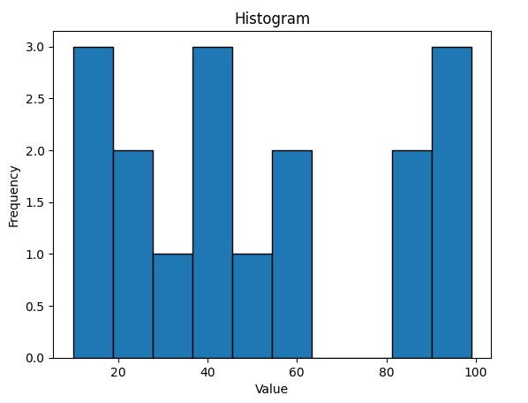

Que 2) In a quant test of the CAT Exam, the population standard deviation is known to be 100. A sample of 25 tests taken has a mean of 520. Construct an 80% CI about the mean.

Confidence Interval = x̄ ± Z \* (σ / √n)

Confidence Interval = 520 ± 1.28 \* (100 / √25)

= 520 ± 25.6

So, the 80% confidence interval about the mean is approximately (494.4, 545.6).

Que 3) A car believes that the percentage of citizens in city ABC that owns a vehicle is 60% or less. A sales manager disagrees with this. He conducted a hypothesis test surveying 250 residents & found that 170 residents responded yes to owning a vehicle.

1. State the null & alternate hypothesis.

Null hypothesis (H0): The percentage of vehicle owners in city ABC is 60% or less.

Alternate hypothesis (H1): The percentage of vehicle owners in city ABC is more than 60%.

1. At a 10% significance level, is there enough evidence to support the idea that vehicle ownership in ABC city is 60% or less?

Number of residents surveyed (n) = 250

Number of residents responding "yes" (x) = 170

Sample proportion (p) = x / n = 170 / 250 = 0.68 (68%)

z = (p - P) / sqrt(P \* (1 - P) / n)

where P is the assumed population proportion (60% = 0.60), p is the sample proportion, and n is the sample size.

z = (0.68 - 0.60) / sqrt(0.60 \* 0.40 / 250)

z = 1.35

At a 10% significance level, we need to find the z-score that corresponds to the upper 10% tail of the standard normal distribution. This critical value is approximately 1.28.

Rejecting the null hypothesis means there is enough evidence to support the idea that vehicle ownership in ABC City is more than 60%.

In conclusion, at a 10% significance level, there is enough evidence to support the sales manager's claim that vehicle ownership in ABC City is more than 60%.

Que 4) what is the value of the 99 percentile?

2,2,3,4,5,5,5,6,7,8,8,8,8,8,9,9,10,11,11,12

Percentile = (Percentile Rank / 100) \* (N + 1)

Percentile = (99 / 100) \* (20 + 1) = 0.99 \* 21 ≈ 20.79

Since we can't have a fractional data point, we can take the 20th data point (which is 12) as the 99th percentile value.

Que 5) In left & right-skewed data, what is the relationship between mean, median & mode?

Draw the graph to represent the same.

In left-skewed (negatively skewed) data, the mean < median < mode.

In right-skewed (positively skewed) data, the mode < median < mean.

